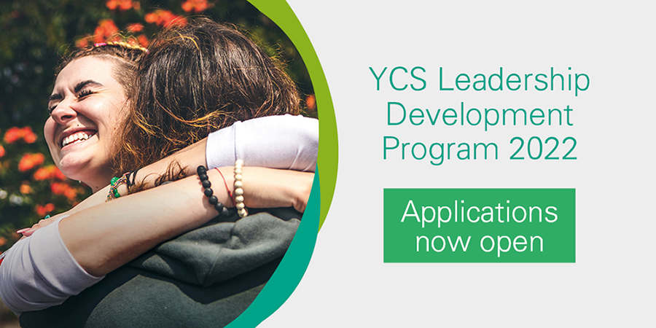

APPLICATION FORM
INSTRUCTIONS
- Complete the application form, including answers to all questions.
- Sign and date the Personal Commitment section.
- Return your completed application to tenley.gillmore@canteen.org.au

Applications close: Monday, 9 May 2022
Applicants notified: Wednesday, 18 May 2022
Program commences: Week starting 30 May 2022

Personal Details
First Name:
Surname:
Role:
Place of work:

Application Questions
- Leadership: What leadership challenges are you currently facing in your role?

- Reason for applying: What in particular has engaged your interest in this program?

- Expectations: What are you hoping to gain from the Leadership Development Program that would support your work and the work of AYA Cancer Services in New Zealand.

- Impact of your learning: What wider benefit do you see AYA care gaining from your participation in the program?

- Commitment to the program: Are you able to make the necessary time commitments to the program?

☐ My Manager is aware that I am applying for the program
☐ I will make myself available for the online modules once a fortnight (block out time in my diary) and the workshop in Sydney on the 9th September 2022.

I, ____________________________________ understand the time commitment required to participate in the YCS Leadership Development Program. If selected, I agree to participate in all activities and workshops outlined in the 2022 timetable. I understand this is a significant investment towards my professional development and, as part of my commitment, I agree to use the learnings of the program to the best of my ability.

Applicant Name:
Applicant Signature:
Date:

